Veecom E1/T1 over 2 Ethernet adaptive
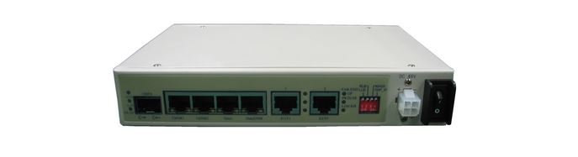

V-IPMUX-SA01/02 adopt the innovative TDM over IP technology, with IP circuit emulation that supports transportation of 1~2 E1 /T1 over FE port, that can be used to provide E1 communication channels over Ethernet or IP networks.
Features:
- IPMUX-SA01 provide 1 channel of E1/T1 over 1 Ethernet adaptive
- IPMUX-SA02 provide 2 channels of E1/T1 over 1 Ethernet adaptive
- Provide 4 FE electrical ports (2 for uplink, 2 for user data or monitoring) and 1 Ethernet optical port optical port can be used for uplink or user data.
- Support IETF RFC4553 SAToP protocol, Ethernet encapsulation support IP/UDP
- User-friendly Web server supported for easy setup and maintenance
- Support SNMP V1/V2 network management
- E1 clock supports 3 mode: local clock, adaptive and loopback
- E1 service support lossless protection
- Ethernet built-in layer 2 switch, support VLAN(802.1Q based and QinQ based), QoS(port based、8021.1P based and TOS based)
- Ethernet support IEEE 802.3x and MAC address automatic learning
- Ethernet packet size up to 9720byte
- Point to point and point to multipoint supported
- Software and hardware online upgrade
- Support SNTP network time setting
- Support software test E1 error
- Support VLAN settings for E1 service and in band VLAN management
- Enough jitter buffer to resist packet delay variation (PDV)
- Local Ethernet port throughput limiting, assuring E1 QoS
- 120ohm balanced E1/T1 port, RJ-45 connector, support 75ohm unbalanced port through outside converting cable
- Support cascade concatenate for more than 16 E1 ports
- Software and hardware online upgrade
- Power supply redundancy.

Typical Application
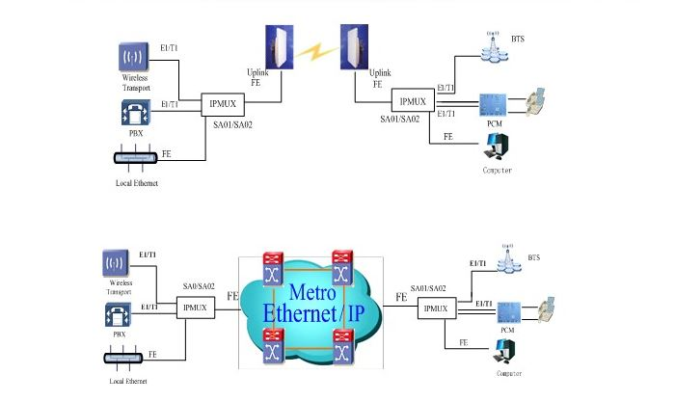
Technical Specifications
Model
- V-IPMUX-SA01/02: 2 uplink, 1/2 E1/T1s
Service card
- Ethernet interfaces
- Speed and duplex auto-netiation or manual
- Comply with IEEE 802.3, 802.1Q, 802.1P, 802.3x
- 4 FE electrical ports and 1 FE optical port
- E1 interface
- V-IPMUX-SA01: 1 E1 ports
- V-IPMUX-SA02: 2 E1 ports
Power
- Supply
- AD or DC
- DC -48V (-32V~-72V)
- AC 220V (100V~265V)
- Consumption: ≤40W
Working Environment
- Temperature: 0~ 50°C
- Relative Humidity: ≤90% (non-condensing)
Dimension
- W x H x D (mm): 185 x 35 x 136.5 (mm)

