Veecom TDM 16xE1 over IP/Ethernet Multiplexer (16xE1+5xGE Electrical ports +1xGE Optical port/SFP). Provide two pluggable E1 cards, each card supports 8 E1s

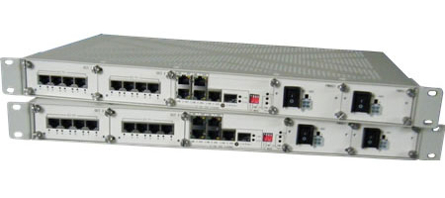

As a cost effective solution for the traditional telecom services migrate to the IP packet networking technology, V-IPMUX-16 adopts the innovative TDM over IP technology, with IP circuit emulation that supports transportation of 8~16 E1s and 5 GE electrical ports and 1 GE optical port. The uplink ports and user data ports are IEEE 802.3 compliant, 10/100/1000M auto-sensed Ethernet ports.
State-of-the-art design provides the highest availability with the accurate timing signal and data bit stream reconstruction. Predefined system parameter profiles that according to different application requirement; ultimately simplify the installation process and saving the maintenance cost. V-IPMUX-16 could work together with other members in V-IPMUX family such as IPMUX-8, IPMUX-4, IPMUX-2, IPMUX-1 etc. to run legacy E1 services. Telecom and Enterprise users can save a lot of access and equipment costs and generates new revenue by offering different types of services over their packet-switched infrastructure. It is also suitable for connecting to the wireless equipment to achieve fast deployment of E1/T1 services. One particular application is to build E1/T1 links with low cost Wireless LAN bridges, replacing much more costly microwave radios. Operators can use V-IPMUX to provide legacy TDM services over wired or wireless Ethernet/IP network.
Features:
- Provide 5 GE electrical ports and 1 GE optical port, 6 GE ports serve as network uplinks or users ports, Anyone of 5 GE electrical ports may act as NM port
- Support Ethernet spanning tree protocol which enable normal work and protection in ring and mesh topology, protection resume in short time
- User-friendly Web server supported for easy setup and maintenance, alarm log provided
- Support SNMP V1/V2 network management
- Ethernet built-in layer 2 switch, support VLAN, comply with IEEE 802.3x, 802.1P
- Provide two pluggable E1 cards, each card supports 8 E1/T1s
- Point to point and point to multipoint supported
- Stable E1 clock recovery, low jitter and wander
- Low processing delay for E1 channels, high bandwidth usage efficiency
- Resist to packet loss, with PCM frame synchronization protection
- User definable encapsulation packet size for different application
- Support Ethernet encapsulation and UDP/IP protocol encapsulation
- Support VLAN settings for E1 service and in band VLAN management
- Enough jitter buffer to resist packet delay variation (PDV)
- Local Ethernet port throughput limiting, assuring E1 QoS
- 120ohm balanced E1/T1 port, RJ-45 connector, support 75ohm unbalanced port through outside converting cable
- Support cascade concatenate for more than 16 E1 ports
- Software and hardware online upgrade
- Power supply redundancy.
Typical Application

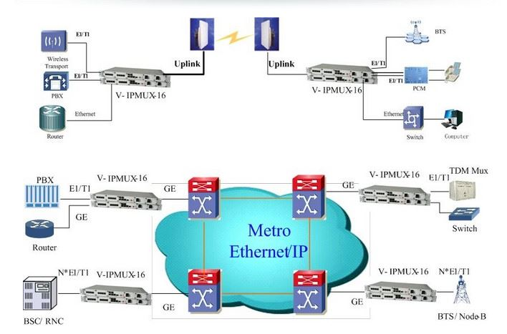

Specifications
Capacity
- It supports 8 or 16 E1 ports, 5 GE electrical ports and 1 GE optical port.
E1 interface
- Comply with ITU-T G.703 recommendation
- Eight E1 Ports Supported.E1 port impedance E1-120Ω for twisted pair cables or 75Ω for coax (The RJ45 E1-120Ω are default for ports)
- End-to-end delay (minimum delay setting) £ 10ms
- Output frequency offset (adaptive timing, stabilized) £ 5 ppm
- Output jitter (adaptive timing) £ 0.1UI
T1 interface
- Frame format: Unframed, SF (D4), ESF
- Bit rate: 1.544Mbps
- Line Code: B8ZS / AMI
- Line impedance: 100 ohms
- Receiving level: 0 to -36dB
- Pulse amplitude: Nominal 3.0V ±20%
- Zero amplitude: ±0.1V
- Transmit frequency tracking : Internal timing±30 ppm
- Loopback timing±50 ppm,
- External timing±100 ppm
- Jitter Performance: According to ITU-T G.824
10/100/1000Base-Tx port
- Comply with IEEE 802.3, 802.1
- 10M/100M/1000M Adaptive
- Half/Full Duplex Adaptive
- Support 802.1Q MAC
- Uplink ports 1+1 backup supported
- Ethernet built-in layer 2 switch function. Support 802.1Q VLAN, 802.1ad Q in Q, 802.1p
Power
- AC:100V~260V/50Hz (fuse: 1A)
- DC:-36V ~ -72V (optional) or dual power supply
- Power Consumption: ≤9W
Operating condition
- Temperature: (0～45) ℃
- Humidity: ≤90％(non-condensing)
Dimensions
- Width × Height × Depth： 440 × 44 × 260 mm
Weight
- ≤ 3.5 kg

